|  |  |  |  |  |  |  |  |
| --- | --- | --- | --- | --- | --- | --- | --- |
| **Pond** | **Dateemerg** | **DD0peakemerg** | **DD1peakemerg** | **DD2peakemerg** | **DD3peakemerg** | **DD4peakemerg** | **DD5peakemerg** |
| East | 6/15/2018 | 5092.14 | 5092.14 | 5092.14 | 5092.14 | 5092.14 | 5092.14 |
| Golf | 6/21/2018 | 6276.10 | 5704.60 | 5133.10 | 4561.60 | 3990.63 | 3427.22 |
| Ice | 6/12/2018 | 7014.10 | 6187.38 | 5400.83 | 4647.19 | 3927.90 | 3277.43 |
| NoOil | 6/9/2018 | 6359.69 | 5694.30 | 5034.26 | 4390.89 | 3767.81 | 3179.04 |
| Oil | 6/16/2018 | 5073.27 | 4320.69 | 3592.55 | 2927.52 | 2338.65 | 1829.23 |
| Vulgaris | 6/21/2018 | 6396.91 | 5681.16 | 4972.21 | 4274.81 | 3592.31 | 2960.82 |
| Vulgarissmall | 6/15/2018 | 6332.75 | 5582.93 | 4881.64 | 4235.77 | 3650.81 | 3118.57 |
| Waterfall | 6/22/2018 | 6461.32 | 5848.14 | 5238.34 | 4635.96 | 4050.53 | 3479.63 |
|  | mean | **6125.78** | **5513.92** | **4918.13** | **4345.74** | **3801.35** | **3295.51** |
|  | sd | **683.64** | **569.28** | **558.95** | **633.51** | **754.70** | **893.33** |
|  | cv | **11.16** | **10.32** | **11.36** | **14.58** | **19.85** | **27.11** |

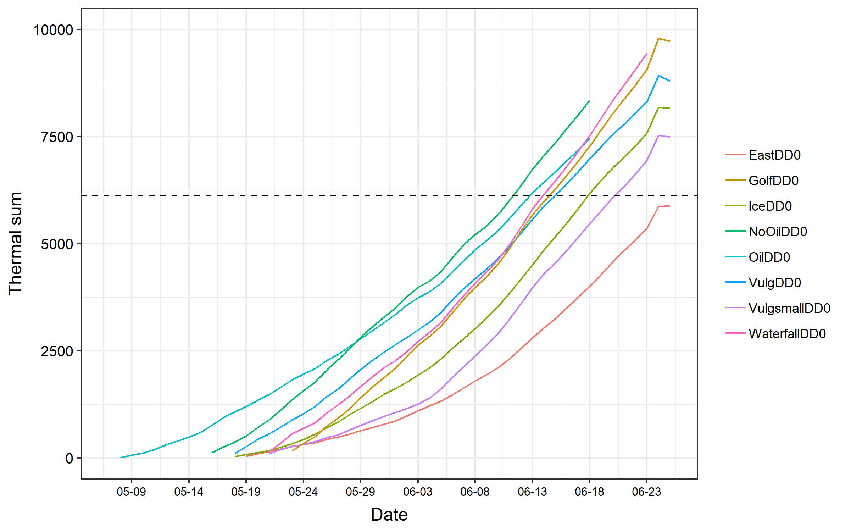

**ignore the funky dip at the end